UI State

🎛️ What is UI State
# Source: AI Source: Provided by: [Data Path: Persons Table -> ID Column: 1, Name_En Column: Motasem Essam] -> From: [ChatGPT] on [1/23/2026]
UI State refers to all the information that represents the current condition of the user interface at any given moment. It’s what determines what the user sees and interacts with.
👉 Think of UI State as a snapshot of the interface — everything that can change while the user interacts with your app.

🔑 Key Points About UI State
# Source: AI Source: Provided by: [Data Path: Persons Table -> ID Column: 1, Name_En Column: Motasem Essam] -> From: [ChatGPT] on [1/23/2026]
- Represents dynamic data of the UI, not the business data itself.
- Can include visibility, selections, inputs, loading indicators, errors, and active tabs.
- Helps keep the UI reactive, so when state changes, the interface updates automatically.
- Usually managed by ViewModel (in MVVM) or Controller (in MVC), depending on the pattern.

🧱 Examples of UI State

1. Form Input
# Source: AI Source: Provided by: [Data Path: Persons Table -> ID Column: 1, Name_En Column: Motasem Essam] -> From: [ChatGPT] on [1/23/2026]
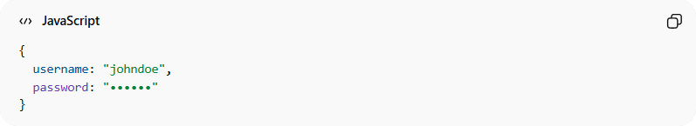
{
username: "johndoe",
password: "••••••"
}

2. Loading / Spinner
# Source: AI Source: Provided by: [Data Path: Persons Table -> ID Column: 1, Name_En Column: Motasem Essam] -> From: [ChatGPT] on [1/23/2026]
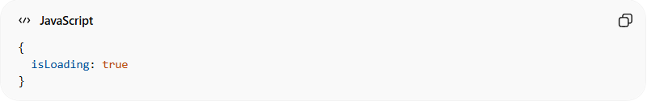
{
isLoading: true
}

3. UI Visibility
# Source: AI Source: Provided by: [Data Path: Persons Table -> ID Column: 1, Name_En Column: Motasem Essam] -> From: [ChatGPT] on [1/23/2026]
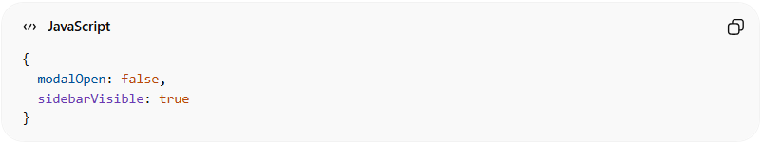
{
modalOpen: false,
sidebarVisible: true
}

4. Selection / Tabs
# Source: AI Source: Provided by: [Data Path: Persons Table -> ID Column: 1, Name_En Column: Motasem Essam] -> From: [ChatGPT] on [1/23/2026]
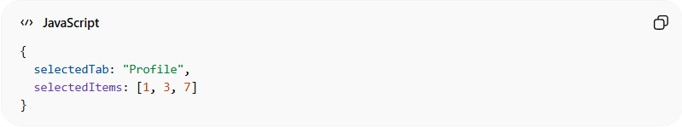
{
selectedTab: "Profile",
selectedItems: [1, 3, 7]
}

🔄 How It Works
# Source: AI Source: Provided by: [Data Path: Persons Table -> ID Column: 1, Name_En Column: Motasem Essam] -> From: [ChatGPT] on [1/23/2026]
- User interacts with the View → triggers events
- ViewModel updates UI State → changes propagate back to View via binding
- The UI automatically reflects the new state
Example: User clicks “Load Users” → isLoading = true → spinner shows → data loads → isLoading = false → spinner hides, list shows users

💡 Summary
# Source: AI Source: Provided by: [Data Path: Persons Table -> ID Column: 1, Name_En Column: Motasem Essam] -> From: [ChatGPT] on [1/23/2026]
UI State = the "memory" of the interface. It tracks everything necessary to render the UI correctly at any moment without directly touching the business logic.

